TAX LEVY ORDINANCE

LISLE TOWNSHIP HIGHWAY DEPARTMENT NOV 21 2013
ORDINANCE No. LEVY2013 d' <i
DuPage County Clerk

An ordinance levying taxes for all road purposes for LISLE TOWNSHIP HIGHWAY DEPARTMENT, Du Page County, Illinois, for the tax year 2013, collectable in 2014.

BE IT ORDAINED by the Board of Trustees of LISLE TOWNSHIP, DuPage County, Illinois, as follows:

SECTION 1: That the Highway Commissioner of LISLE TOWNSHIP HIGHWAY DEPARTMENT on November 13, 2013 does hereby determine and declare that the sum of THREE MILLION SIXTY-SEVEN THOUSAND DOLLARS ($3,067,000)
is hereby levied upon all property subject to taxation within the Highway Department as that property is assessed and equalized, in order to meet and defray all the necessary expenses and liabilities of the Highway Department as required by statute or voted by the people in accordance with the law, for such purposes as:

-GENERAL ROAD FUND
-INSURANCE FUND
-IMRF FUND
-SOCIAL SECURITY FUND
-PERMANENT ROAD FUND
-EQUIPMENT & BUILDING FUND

for the year 2013.

SECTION 2: That the amount levied for each object and purpose shall be as follows:

GENERAL ROAD FUND

ADMINISTRATION & MAINTENANCE Expenditures
CITY'S & VILLAGE$' SHARE
Expenditures

$ 199,360

156,640
Amount Levied

TOTAL GENERAL ROAD FUND:
REF: General Road & Bridge Tax (605 ILCS 5/6-501 & 5/6-504)
$ 356,000
--------

page one

INSURANCE FUND

Expenditures .

TOTAL INSURANCE FUND:
REF: Insurance Tax [7451LCS 1 0/9 -107)

ILLINOIS MUNICIPAL RETIREMENT FUND (IMRF)

Expenditures

TOTAL IMRF FUND:
REF: IMRF Tax (40 ILCS 5/7- 171)

Amount Levied

$ 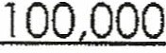

$ 100,000
--------

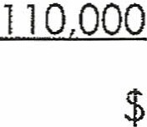$

110,000
--- -.
-- - - --- -

SOCIAL SECURITY FUND

Expenditures

TOTAL SOCIAL SECURITY FUND:

$ 30,000

$

30,000

REF: Social Security Tax (40 ILCS 5/21 -1 10 & 5/21 -1 10.1)

PERMANENT ROAD FUND

Expenditures

TOTAL PERMANENT ROAD FUND:
REF: Permanent Road Tax (IRS, Ch 121, Par 6-601) (6051LCS 5/6-601 )

EQUIPMENT & BUILDING FUND

Expenditures

TOTAL EQUIPMENT & BUILDING FUND:
REF: Equipment & Building Tax (605 ILCS 5/6-508.1 )

TAX LEVY SUMMARY:

TOTAL TAXES LEVIED: Amount to be levied was determined b
Highway Department.
--------

$ 2,281,000

$ . 2,281,000
--------

$ 190,000

$ 190,000
Road & Bridge Tax | $ 356,000
Insurance Tax | 100,000
Illinois Municipal Retirement Tax | 110,000
Social Security Tax | 30,000
Permanent Road Tax | 2,281,000
Equipment & Building Tax | 190,000

$ 3,067,000
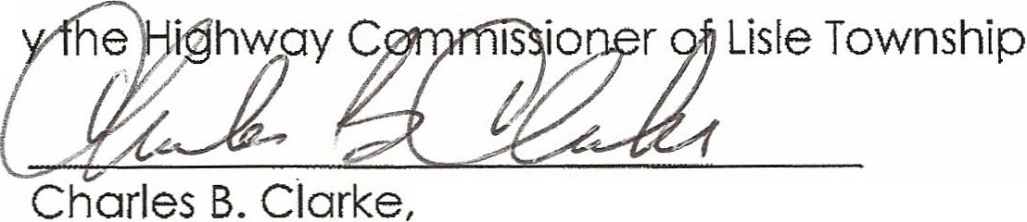--------

Highway Commissioner

- page two

SECTION 3: . That the Town Clerk shall file with the County Clerk of said County of DuPage, on or before the last Tuesday of December, a duly certified copy of this ordinance.

SECTION 4: That the Board of Trustees does hereby certify that the amount levied herein is necessary to be raised by taxation for road purposes for LISLE TOWNSHIP HIGHWAY DEPARTMENT.

SECTION 5: That if any section, subdivision, or sentence of this ordinance shall for any reason be held invalid or to be unconstitutional, such finding shall not affect the validity of the remaining portion of this ordinance.

SECTION 6: That this ordinance shall be in full force and effect after its adoption, as provided by law.

ADOPTED this 13th day of November, 2013, pursuant to a roll call vote by the

Board of Trustees of LISLE TOWNSHIP, Du Page County, Illinois.

BOARD OF TRUSTEES ABSENT

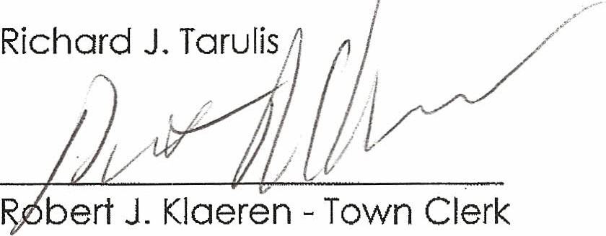Sharon Connell Michael Riedy Michael Toms Ed Young

/ --
y:

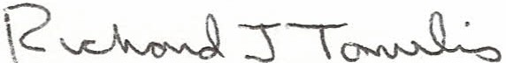

Richard J. Tarulis - Chairman, Board of Trustees

............ - '-"' ..... J - •
.:; ;..------------..._:

-./ '-
..:::-. / /. _ ·· . -- 2- page three
- .
.......· . - .........
- - ..........._
_........ _ -

Town of Lisle
County of DuPage

CERTIFICATE OF COMPLIANCE TRUTH IN TAXATION
ROAD AND BRIDGE LEVY

The undersigned, presiding officer of LISLE TOWNSHIP IDGHWAY DEPARTMENT does hereby certify that the Levy Ordinance, a copy of which is attached hereto, was adopted pursuant to, and in compliance with or iq-, pplicability of the provisions of Sections
4 through 7 of"TRUTH IN TAXATION ACT." Public Act 82-102 (ffiS, CH 120,
SECTION 861-869.1)

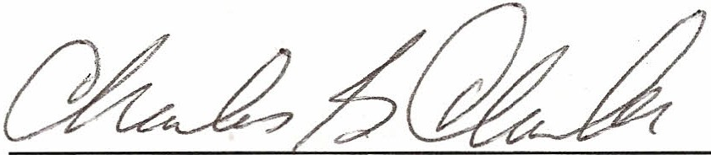DATE: 11 I 13 I 2013

Presiding Officer
Charles B. Clarke

CERTIFICATION OF TAX LEVY ORDINANCE

LISLE TOWNSHIP HIGHWAY DEPARTMENT

The undersigned, duly elected, qualified and acting Clerk of Lisle Township Highway Department, DuPage County, Illinois, does hereby certify that the attached hereto is a true and correct copy of the Tax Levy Ordinance, of said Township Highway Department for the year 2013, as adopted this 13th day of November, 2013.

This certification is made and filed pursuant to the requirements of (60 ILCS
1/75-20) and on behalf of Lisle Township Highway Department, DuPage County, Illinois. This certification must be filed by the last Tuesday in December.

Dated the 13th day of November, 2013.

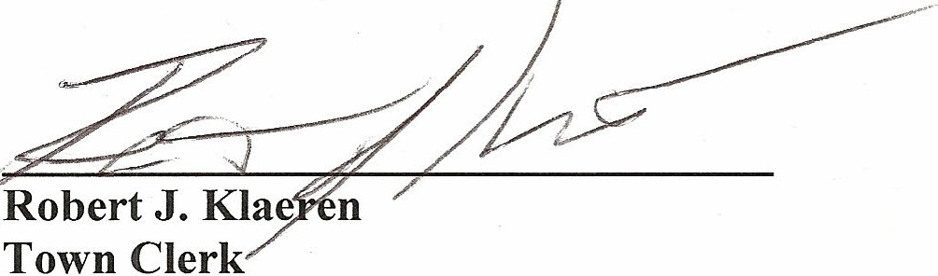

Filed this day of 2013. County Clerk

