LISLE TOWNSIDP
NOV 21 2013'

ORDINANCE 2013-3 c:l
DuPage County Clerk An ordinance levying taxes for all town purposes for Lisle Township, DuPage County, Illinois, for the tax year 2013 collectible in 2014.

WHEREAS, the Supervisor and Board of Trustees have previously adopted a budget for

the fiscal year 2013-2014, and determined the estimated amount of funds to be raised by taxation for the calendar year 2014; and
WHEREAS, a legal notice pursuant to the Truth In Taxation Act was published, and a public hearing held, prior to adoption of this Ordinance.
NOW THEREFORE, be it ordained by the Supervisor and Board of Trustees of Lisle

Township, DuPage County, Illinois as follows:

SECTION 1: That the sum of Two Million, Four Hundred Ninety One Thousand, Two Hundred Fifty Dollars ($2,491,250.00) is hereby levied upon all property subject to taxation within the Township as that property is assessed and equalized, in order to meet and defray all the necessary expenses and liabilities of the Township as required by statute or voted by the people in accordance with the law.
SECTION 2: That the amount levied for each object and purpose shall be as follows:

TOWN FUND

Purpose

Assessor
Employee Salaries

IMRF

Voluntary Additional IMRF FICA
Travel/Training Telephone/Internet/Computers Office Equip./Maint./Supplies Total Assessor
Town Hall
Insurance (Bldg., Liab., Auto, Misc.) Building Utilities
Building Maintenance Capital Improvements Total Town Hall
Administration

Staff Salaries

IMRF

Voluntary Additional IMRF FICA
Workman's Comp. Ins. Unemployment Ins. Health & Dental Ins.

$ 515,000.00

$ 100,000.00

$ 40,000.00

$ 40,000.00

$ 20,000.00

$ 25,000.00

$ 15,000.00

$ 50,000.00

$ 40,000.00

$ 50,000.00

$ 320,000.00

$ 200,000.00

$ 95,000.00

$ 35,000.00

$ 40,000.00

$ 56,000.00

$ 5,000.00

$ 245,000.00
Amount Levied

$ 755,000.00

$ 460,000.00

Travel/Training | $ 7,000.00
Computers/Office Equip. | $ 10,000.00
Software/IT/Web | $ 18,000.00
Audit | $ 7,500.00
Legal | $ 5,000.00
Total Administration |  | $ 723,500.00

Special Programs
Mosquito Control $ 75,000.00

Transportation $ 75,000.00

Community Career Center $ 5,000.00

Access DuPage $ 5,000.00

Cornrn. Emergency Response Team $ 5,750.00

Total Special Programs $ 165,750.00

Social Services
Job Club Expenses $ 4,000.00

Job Fair $ 5,000.00

Intern Scholarships $ 5,000.00

Training $ 2,000.00

Total Social Services $ 16,000.00

TOTALTOWNFUNDTAXLEVY $ 2,120,250.00

GENERAL ASSISTANCE FUND

Purpose Amount Levied

Home Relief Expenses
Food Rent Utilities
Medical Care Transportation Catastrophic Insurance Total Home Relief
Emergency Hospital/Institutional Care

Administration
Staff Salaries

IMRF

Voluntary Additional IMRF FICA
Health & Dental Ins. Food Pantry
Van maintenance/Gas

$ 50,000.00

$ 34,000.00

$ 13,000.00

$ 10,000.00

$ 15,000.00

$ 30,000.00

$ 120,000.00

$ 25,000.00

$ 9,000.00

$ 10,000.00

$ 20,000.00

$ 15,000.00

$ 10,000.00

$ 152,000.00

$ 10,000.00

Total Administration $ 209,000.00

TOTAL GENERAL ASSISTANCE FUND TAX LEVY $ 371,000.00

TOTAL TAXES LEVIED $ 2,491,250.00

SECTION 3: That the Town Clerk shall make and file with the County Clerk of said County ofDuPage, on or before the last Tuesday of December, a duly certified copy of this ordinance.
SECTION 4: That if any section, subdivision, or sentence of this ordinance shall for any reason be held invalid or to be unconstitutional, such finding shall not effect the validity of the remaining pQition of this ordinance.
SECTION 5: That this ordinance shall be in full force and effect after its adoption, as provided by law.
ADOPTED this 13th day ofNovember, 2013, pursuant to a roll call vote by the Board of

Trustees of Lisle Township, DuPage County, Illinois.

BOARD OF TRUSTEES  Michael Tams | 9(,_ | NAY  0 | ABSENT  0
Michael Riedy | ti | 0 | 0
Sharon Connell | 0 | 0
Ed Young | lSI( | 0 | 0
Richard J Tarulis, Supervisor | R | 0 | 0

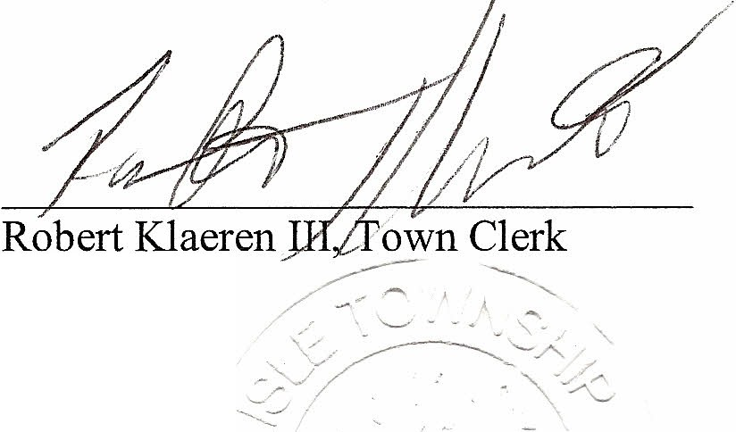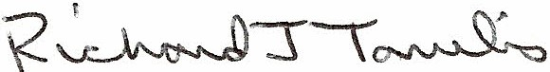Richard J Tarulis, Township Supervisor

(SEAL)

_.......
'.- ' - .._.

Lisle Township
County of DuPage

CERTIFICATE OF COMPLIANCE TRUTH IN TAXATION

The undersigned, presiding officer of LISLE TOWNSHIP does hereby certify that the Tax Levy Ordinance, a copy of which is attached hereto, was adopted pursuant to and in compliance with or inapplicability of the provisions of Sections 18-60 through 18-85 of "TRUTH IN TAXATION LAW". (35 ILCS200/18-55)

DATE: November 13, 2013

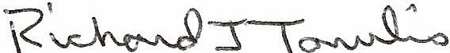
Presiding Officer

CERTIFICATION OF TAX LEVY ORDINANCE LISLE TOWNSHIP

The undersigned, duly elected, qualified and acting Clerk of Lisle Township, DuPage County, Illinois, does hereby certify that the attached hereto is a true and correct copy of the Tax Levy Ordinance, of said Township for the year 2013, as adopted this 13th day of November, 2013.

Dated this day ofNovember 13, 2013.
